**Machine Learning**

Contents

Notation 2

Hypotheses 3

Cost functions 4

Cost minimisation 5

Train/dev/test distributions 6

Model diagnostics (Bias/Variance analysis and Error analysis) 7

Regularization 14

Support Vector Machines (SVM) 15

Neural Networks 16

Convolutional neural networks 18

Recurrent neural networks 26

NLP / Attention / Transformer 43

Unsupervised Learning 44

Large scale machine learning 48

Appendix A: Matrix algebra 49

Appendix B: Derivatives 51

Appendix C: ML hardware 52

### Notation

θ = parameter/weight

hθ(x) = hypothesis function

α = learning rate

m = number of training examples

n = number of features

Xj(i) = value of feature j in the ith training example

X(i) = input features of ith training training exaple

J = cost function

Neural network additional variables:

L = total number of layers in the network

l = specific layer

*sl*​ - number of units (not counting bias unit) in layer l

K = number of output units/classes

Θ(l)j,i = parameter/weight matrix, where number of columns equals number of nodes on current later (l), and number of rows equals number of nodes in next layer (excluding bias unit)

Δ*i*,*j*(*l*)

D(l)i,j

μ = mean

σ = standard deviation

σ2  = variance

CNN additional notations:

n(l)H, n(l)W and n(l)C denote respectively the height, width and number of channels of a given layer (l)

### Hypotheses

Function which takes in x and predicts y

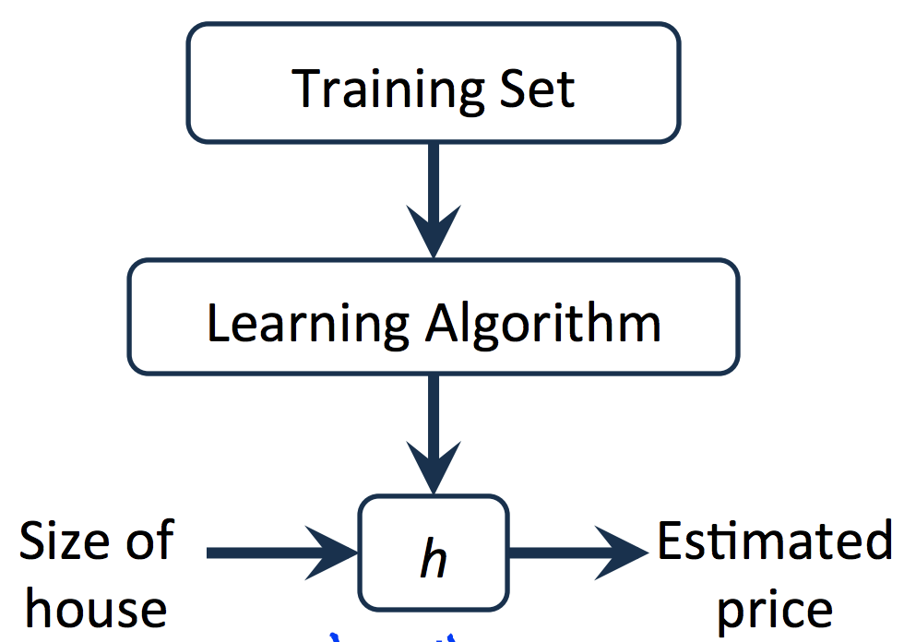

Linear regression with one variable:

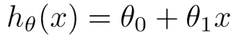

Multivariate linear regression:

 OR

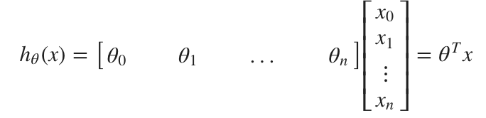

Logistic regression:

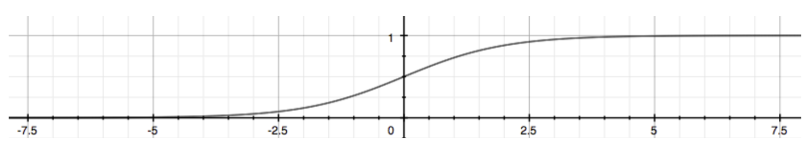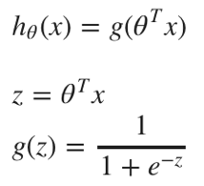

In order to get our discrete 0 or 1 classification, we can translate the output of the hypothesis function as follows:

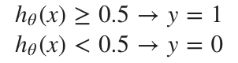

The way our logistic function g behaves is that when its input is greater than or equal to zero, its output is greater than or equal to 0.5: g(z)≥0.5 when z≥0 . This translates to:

θTx ≥ 0 ⇒ y=1

θTx < 0 ⇒ y=0

The **decision boundary** is the line that separates the area where y = 0 and where y = 1. It is created by our hypothesis function.

### Cost functions

Measure of the accuracy of our hypothesis function

Linear regression:

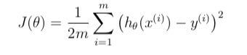

Plot of cost function (Y axis) against two parameters (X axis)

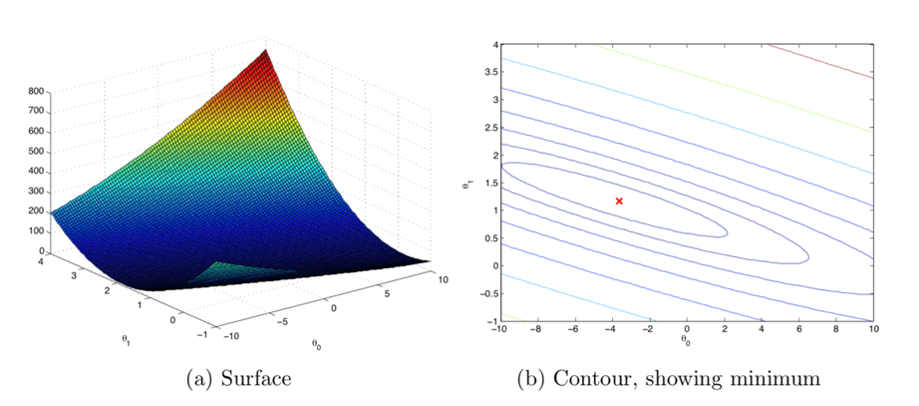

Logistic regression:

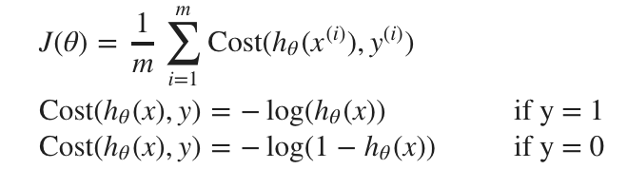

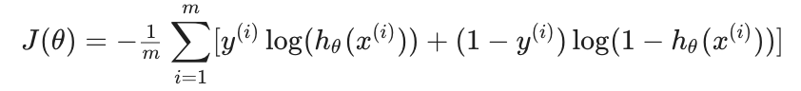

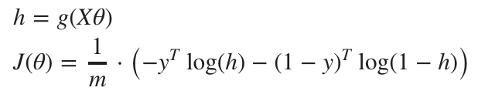

The gradient of the logistic regression cost is a vector where the jth element is defined as:

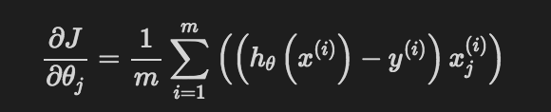

Neural Networks:



Gradient is an "unrolled" vector of the partial derivatives of the concatenation of all the neural network weights.

### Cost minimisation

Gradient Descent - optimization algorithm used to minimize cost function by iteratively moving in the direction of **steepest descent** by changing model parameters. Typically used in linear and logistic regression

Linear/Logistic regression:

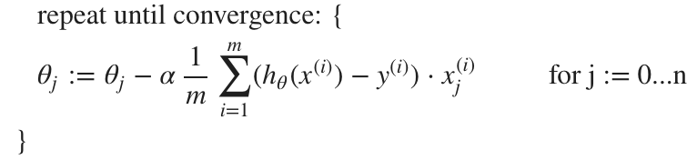

Neural Network:

"Backpropagation" - is neural-network terminology for minimizing our cost function rather than Gradient descent. Backpropagation algorithm:

Given training set {(x(1),y(1))⋯(x(m),y(m))}:

Set Δ*i*,*j*(*l*) = 0 for all (l, i, j)

For training example t=1 to m:

* Set *a*(1) := *x*(*t*)
* Perform forward propagation to compute all the activations throughout the network i.e. *a*(*l*) for l=2, 3, …, L
* Then, for each node j in layer l, we compute an “error term” δ(l) j that measures how much that node was “responsible” for any errors in our output. For an output node, we can directly measure the difference between the network’s activation and the true target value i.e. compute *δ*(*L*) = *a*(*L*)−*y*(*t*).
* For nodes in the hidden layers, calculate delta values by multiplying the delta values in the next layer with the theta matrix of the layer in question i.e. compute

*δ*(*L*−1), *δ*(*L*−2), …, *δ*(2) using δ(l) = Θ(l).T.dot(δ(l+1))  We then element-wise multiply that with a function called g', or g-prime, which is the derivative of the activation function g evaluated with the input values given by z(l)

* Accumulate the gradient from this example using the following formula;

Δ(*l*) := Δ(*l*) + *δ*(*l*+1).dot(*a*(*l*)). *T*

* Hence we update our new Δ matrix.
  + D(l)i,j:=1/m(Δ(l)i,j+λΘ(l)i,j), if j≠0.
  + D(l)i,j := *1/m*​Δ*i*,*j*(*l*)​ If j=0
* The capital-delta matrix D is used as an "accumulator" to add up our values as we go along and eventually compute our partial derivative. Thus we get ∂∂Θ(l)ijJ(Θ)= *Dij*(*l*)​

### Train/dev/test distributions

Test and Dev set should come from the same distribution and should reflect data you expect to get in the future and you want to do well on

Train/dev/test set distribution depends on quantity of data you have

Old rule of thumb: 70/30 train/dev split or 60/20/20 train/dev/test split

But with more data these days, possible to reduce proportion in dev/test

Current guidance – set dev set large enough to give high confidence in overall performance of your system

The dev/test set should contain the data that you expect to receive going forward. E.g. if you have 1000 web images, and only 50 app images, but your algorithm needs to be good at classifying app images, a significant portion of the app images (e.g. 50% +) should go into dev/test set and no web images need to go into dev set as there is no point optimizing this

### Model diagnostics (Bias/Variance analysis and Error analysis)

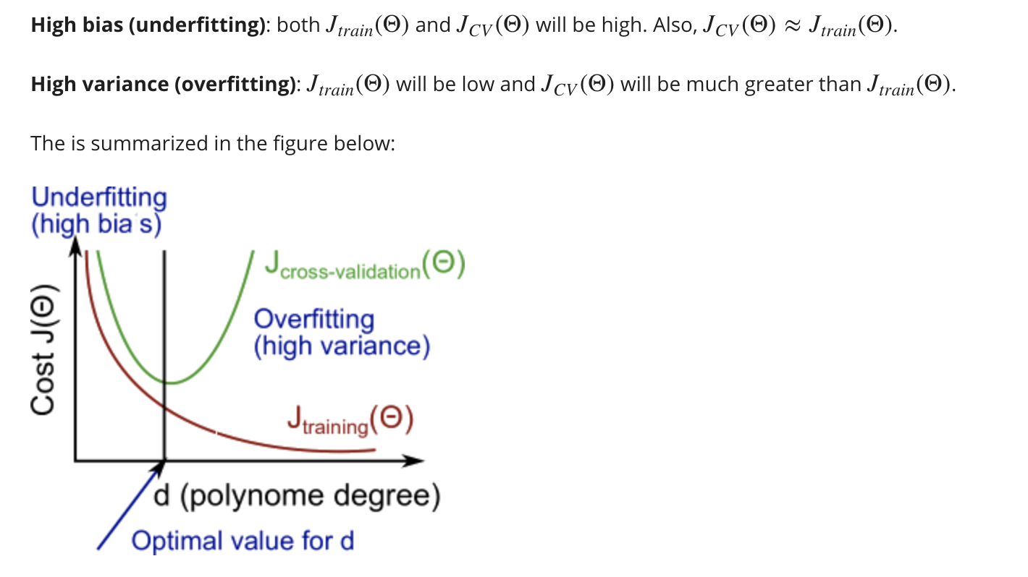

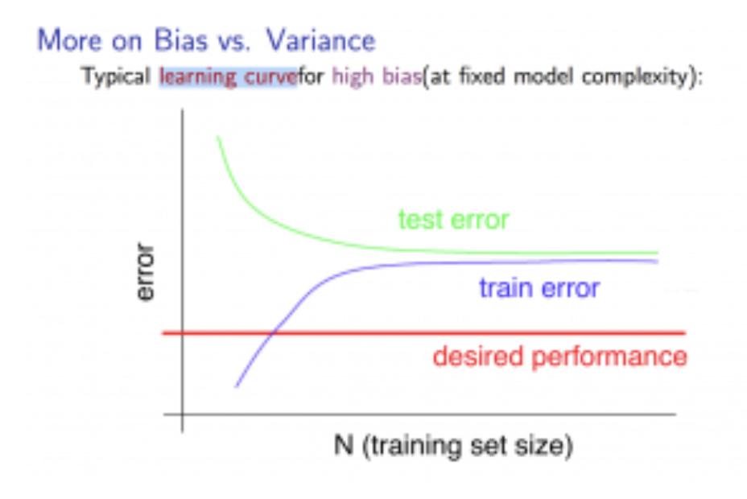

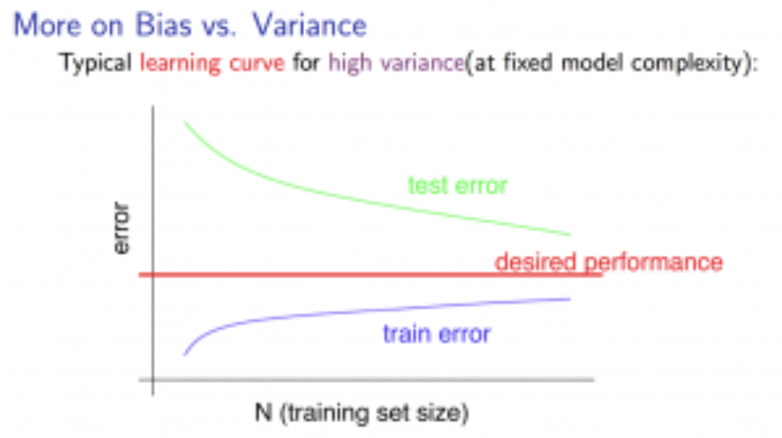

Our decision process can be broken down as follows:

* **Getting more training examples:** Fixes high variance
* **Trying smaller sets of features:** Fixes high variance
* **Adding features:** Fixes high bias
* **Adding polynomial features:** Fixes high bias
* **Decreasing λ:** Fixes high bias
* **Increasing λ:** Fixes high variance.

**Diagnosing Neural Networks specifically:**

* A neural network with fewer parameters is **prone to underfitting**. It is also **computationally cheaper**.
* A large neural network with more parameters is **prone to overfitting**. It is also **computationally expensive**. In this case you can use regularization (increase λ) to address the overfitting.

Using a single hidden layer is a good starting default. You can train your neural network on a number of hidden layers using your cross validation set. You can then select the one that performs best.

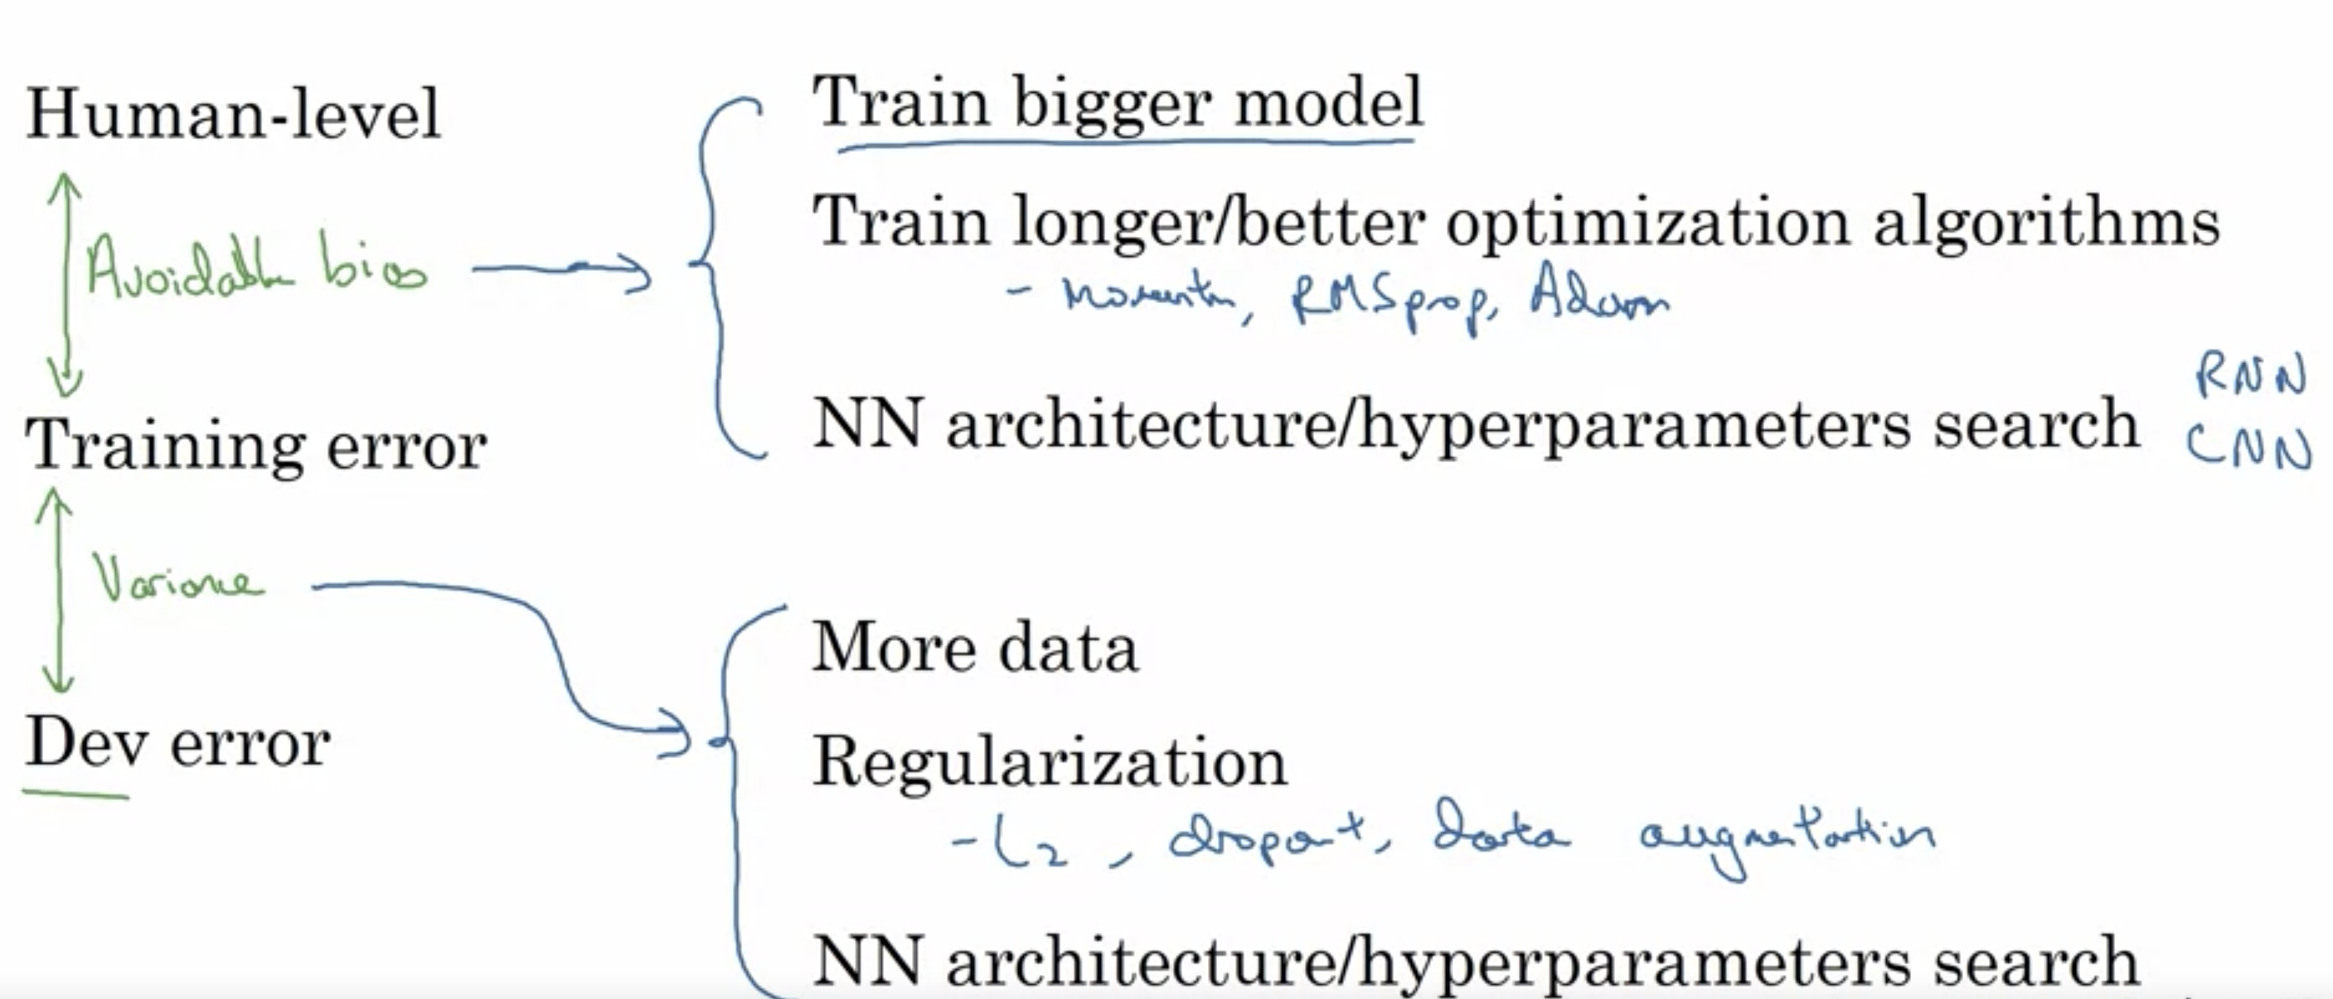

Bias/variance analysis changes when your training set and dev/test set come from different distributions. In these cases, it’s good practice to create a ‘training-dev’ set which has the same distribution as the dev/test then. Then by comparing error rate on t-dev set and dev set you can work out if you have a variance problem (similar t-dev performance to dev set) or a data distribution mismatch problem

**Model Complexity Effects:**

* Lower-order polynomials (low model complexity) have high bias and low variance. In this case, the model fits poorly consistently.
* Higher-order polynomials (high model complexity) fit the training data extremely well and the test data extremely poorly. These have low bias on the training data, but very high variance.
* In reality, we would want to choose a model somewhere in between, that can generalize well but also fits the data reasonably well.

To reduce overfitting, you can either

1) Reduce the number of features:

* Manually select which features to keep.
* Use a model selection algorithm (studied later in the course).

2) Regularization

* Keep all the features, but reduce the magnitude of parameters ​.
* Regularization works well when we have a lot of slightly useful features.

**Error analysis**

The recommended approach to solving machine learning problems is to:

* Start with a simple algorithm, implement it quickly, and test it early on your cross validation data.
* Plot learning curves to decide if more data, more features, etc. are likely to help.
* Manually examine the errors on examples in the cross validation set and try to spot a trend where most of the errors were made (error analysis):

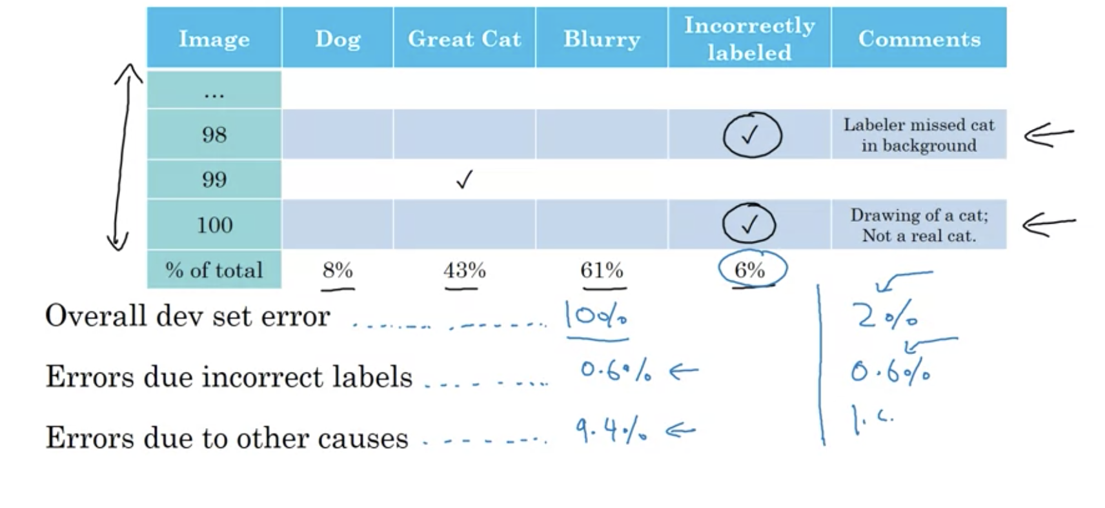

E.g in image above, ‘great cat’ seems to be causing majority of error, so focus time on that

**Ceiling analysis** - process of manually overriding each component in your system to provide 100% accurate predictions with that component. Thereafter, you can observe the overall improvement of your deep learning system component by component.

**Dealing with incorrectly labelled data**

Training set:

* If the errors are reasonably random, then it's okay to just leave them
* If the errors are systematic, then it’s worth fixing them as classifier will otherwise learn incorrectly

Dev/test set:

* during error analysis to add one extra column so that you can also count up the number of examples where the label Y was incorrect to see how prevalent the mislabelling is
* if it makes a significant difference to your ability to evaluate algorithms on your dev set (i.e. the % of incorrect labels out of total dev/test errors) then go ahead and spend the time to fix incorrect labels.
* Make sure to apply whatever process you apply to both your dev and test sets at the same time (to ensure they both have same distribution)
* Also consider examining examples your algorithm got right as well as ones it got wrong (it could be that the algorithm was wrong, but classified as right because of mislabelling)
* Finally, if you go into a dev and test data to correct some of the labels there, you may or may not decide to go and apply the same process for the training set (it’s not critical as they do not need ot be from same distribution)

**Artificial data synthesis**

**Transfer learning and multi-task learning**

**Transfer learning** is a **machine learning** technique where a model trained on one task (A) is re-purposed on a second related task (B)

Makes sense when:

* Task A and B have same input X
* You have a lot more data for Task A than Task B
* Low level features from A (edges, lines etc) can help with B

Process:

* If only small data set for B, remove last layer of NN trained on A, replace the dataset with B and retrain the final weights on dataset B
* If relatively large data for B, same as above but you can re-train more layers in the NN

Multi-task learning: multiple learning tasks are solved at the same time with a single neural network, while exploiting commonalities and differences across tasks. E.g. an image with multiple labels

Makes sense when:

* Training on set of tasks that could benefit from having shared lower-level features
* Usually: amount of data for each task is similar
* Can training a big enough neural network to do well on all tasks

**End-to-end deep learning**

**End-to-end** (**E2E**) **learning** refers to training a **learning** system represented by a single model (specifically a **Deep Neural Network**) that represents the complete target system, bypassing the intermediate layers usually present in traditional pipeline designs

Pros:

* Let’s the data speak (no human intervention)
* Less hand designing of components

Cons:

* May need large amounts of data (this is a key question: need to see whether you have enough data such that a single model might do a good job)
* Excludes potentially useful hand-designed components

**Accuracy measures**

Confusion matrix:

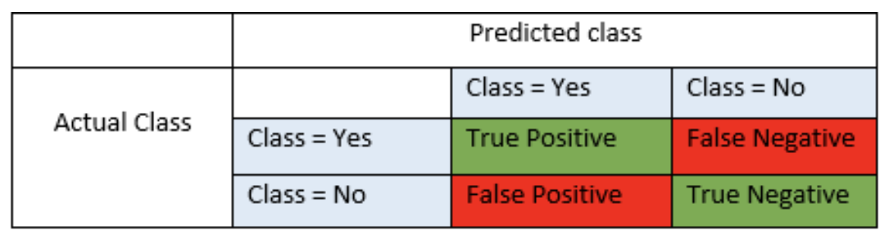

True Positives (TP) - These are the correctly predicted positive values

True Negatives (TN) - These are the correctly predicted negative values

False Positives (FP) – When actual class is no and predicted class is yes

False Negatives (FN) – When actual class is yes but predicted class in no

Accuracy = TP+TN/TP+FP+FN+TN

the number of correct predictions made by the model by the total number of people sampled

Precision = TP/TP+FP

Of all people that we predicted to have cancer, what fraction actually had cancer

Recall = TP/TP+FN

Of all patients that actually have cancer, what fraction did we predict as having cancer

F1

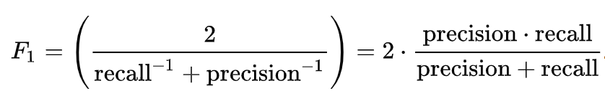

It is useful to use a single optimizing metric to track progress (F1 usually a good one to use).

However you might also want to include one or more satisficing metrics such as “must achieve runtime of no more than X seconds”

### Regularization

 form of regression, that constrains/ regularizes or shrinks the coefficient estimates towards zero

Cost function for linear regression:

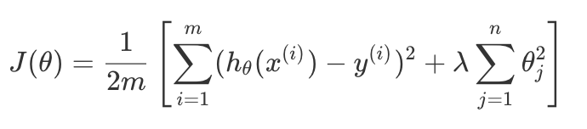

Cost function for logistic regression:



The λ, or lambda, is the **regularization parameter**. It determines how much the costs of our theta parameters are inflated. The higher lambda, the more high coefficients are penalised, so the more reduced your fitting will be.

In order to choose the model and the regularization term λ, we need to:

1. Create a list of lambdas (i.e. λ∈{0,0.01,0.02,0.04,0.08,0.16,0.32,0.64,1.28,2.56,5.12,10.24});
2. Create a set of models with different degrees or any other variants.
3. Iterate through the *λ*s and for each *λ* go through all the models to learn some Θ.
4. Compute the cross validation error using the learned Θ (computed with λ) on the JCV(Θ) **without** regularization or λ = 0.
5. Select the best combo that produces the lowest error on the cross validation set.
6. Using the best combo Θ and λ, apply it on Jtest(Θ) to see if it has a good generalization of the problem.

### Support Vector Machines (SVM)

Need to specify parameter C (this acts similarly to 1/lambda),

Also need to specify choice of kernel (similarity function):

* Linear kernel: gives you a linear classifier (predict y = 1 if Theta.T*x > 0). Use this when n is large and m is small.
* Gaussian kernel:.

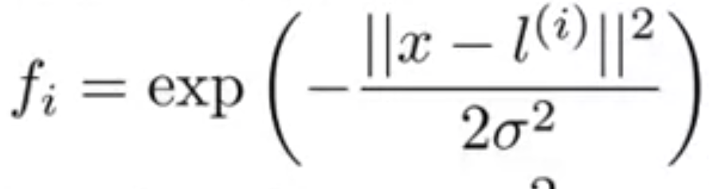

Non-linear. Use when m is large and n is small

### Neural Networks

Neurons - computational units that take inputs (**dendrites**) as electrical inputs (called "spikes") that are channelled to outputs (**axons**). In our model, our dendrites are like the input features x1⋯xn, and the output is the result of our hypothesis function

Activation function – same as a logistic function. There is an activation function at each node in the network

Weights – same as parameters (theta)

Input layer - Our input nodes (layer 1)

Output layer – the final output of the hypothesis function

Hidden Layers - intermediate layers of nodes between the input and output layers

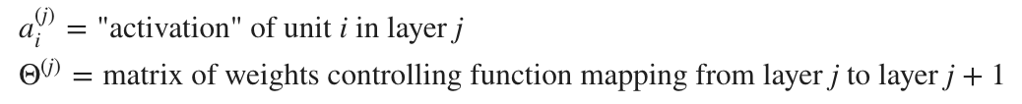

Neural network with a single hidden layer:

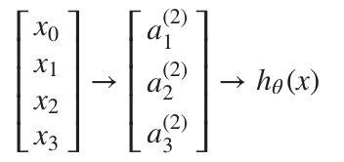

Value for each activation node is obtained as:

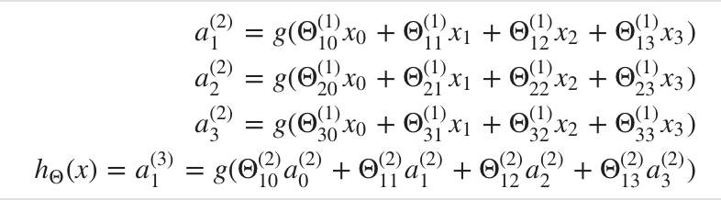

This is saying that we compute our activation nodes by using a 3×4 matrix of parameters. We apply each row of the parameters to our inputs to obtain the value for one activation node. Our hypothesis output is the logistic function applied to the sum of the values of our activation nodes, which have been multiplied by yet another parameter matrix Θ(2) containing the weights for our second layer of nodes.

Each layer gets its own matrix of weights, Θ(j).

The dimensions of these matrices of weights is determined as follows:

If network has sj units in layer j and sj+1 units in layer j+1, then Θ(j) will be of dimension sj+1×(sj+1).

The +1 comes from the addition in Θ(j) of the "bias nodes," x_0*x*0​ and Θ(j)0. In other words the output nodes will not include the bias nodes while the inputs will.

### Convolutional neural networks

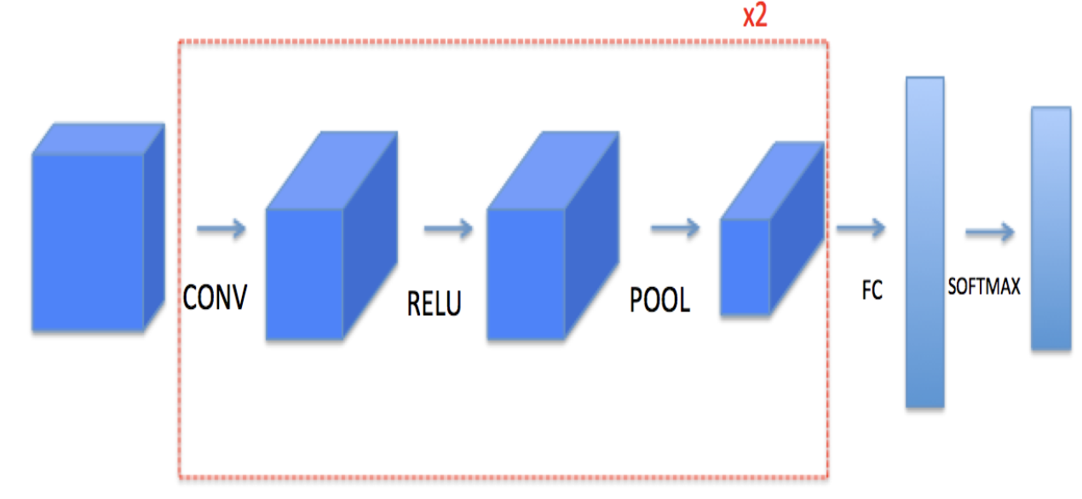

**Motivation**

If you use standard NN on large images you can end up with millions of parameters, which can be time consuming to train, and also can lead to overfitting if you do not have enough data.

By using CNNs you achieve:

* 1. Parameter sharing – a feature detector that’s useful in one part of image is useful in another part
  2. Sparsity of connections – in each layer, each output value depends only on a small number of inputs (i.e. the inputs in the window only rather than the whole image)

**Key terms**

**Filter** - a matrix or volume of learnable weights that is slid over and convolved over an image in order to produce a filtered output

**Convolution**

* takes an input volume
* Applies a filter at every position of the input – multiply the filter’s values element-wise with the window matrix, sum them up, and adding a bias
* Outputs another volume (usually of different size)

**Padding** – adding border to the image (usually with 0 values). Main benefits:

* 1. Allows you to use CONV layer without shrinking height/width of volumes
  2. Helps keep more information near the border of image (without padding, pixels in the edges would not pass through a filter as often as pixels in the centre)

**Strides -** amount you move the window each time you slide

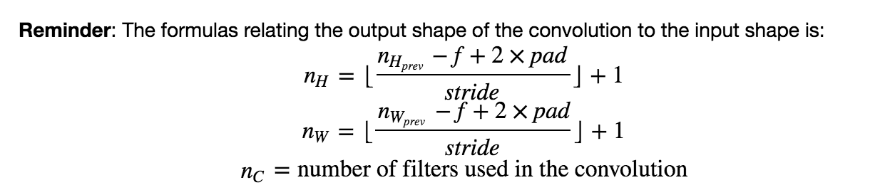

**Pooling layer -** reduces the height and width of the input. It helps reduce computation, as well as helps make feature detectors more invariant to its position in the input. The two types of pooling layers are:

* Max-pooling layer: slides an (f,f) window over the input and stores the max value of the window in the output.
* Average-pooling layer: slides an (f,f) window over the input and stores the average value of the window in the output.

Parameters you need to define are filter size and stride. These are fixed (not learned parameters)

If layer l is a convolution layer:

Each filter is f(l) x f(l) x nc(l-1)

Activations: m x nh(l) x nw(l) x nc(l)

Weights: f(l) x f(l) x nc(l-1) x nc(l)

Bias: nc(l)

**Residual networks**

* Deeper networks are able to represent very complex functions
* They can also learn features at many different levels of abstraction (e.g. edges to more complex features)
* Huge barrier to deeper networks is vanishing gradients – gradient goes to zero quickly hence gradient descent becomes extremely slow (gradient goes to zero quickly because you multiply by the weight matrix at each step)
* Residual networks can overcome this by using a ‘shortcut’ or skip connection that allows the model to skip layers
* Example of a ResNet block on the right, compared to a normal ConvNet:

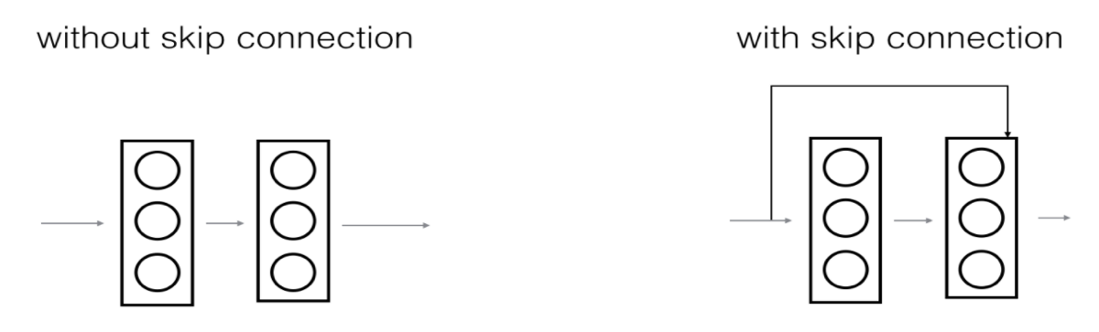

* Additional benefit of using a ResNet is that it makes it very easy for one of the blocks learn an identity function which means you can stack on additional ResNet blocks with little risk of harming performance
* Two main types of blocks used in ResNet: identity block and convolutional block
* Identity block is corresponds to case where input activation has the same dimension as output activation, which means that you simply take x (shortcut) and add it to x:

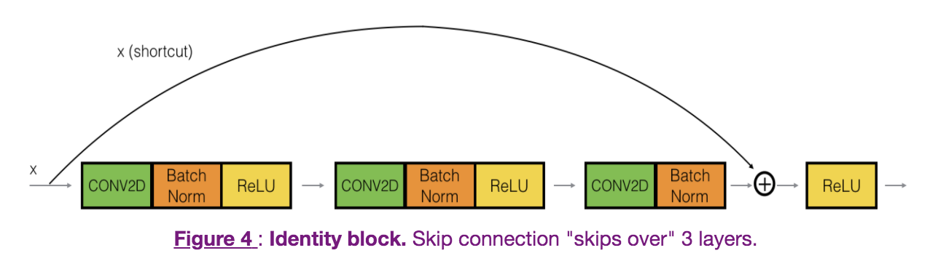

* A convolutional block is used when the input and output dimensions do not match up. Therefore you need to add a CONV2D layer in the shortcut path:

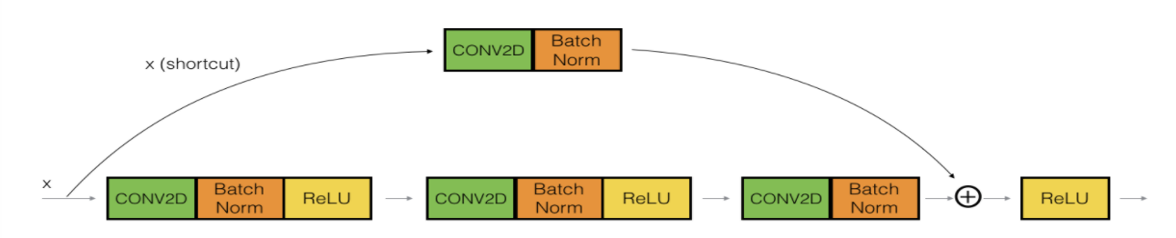

**Inception Networks and 1x1 convolutional layers**

TODO

**Object detection**

* Classification: looks at picture and says this is a car
* Classification with localisation: as well as label as a car, put a bounding box around position of the car
* Object detection: might be multiple objects in the picture and you have to detect them all and localise them all
* If you want to localise as well as classify, you need to add a few more output units to your neural network that output a bounding box
* 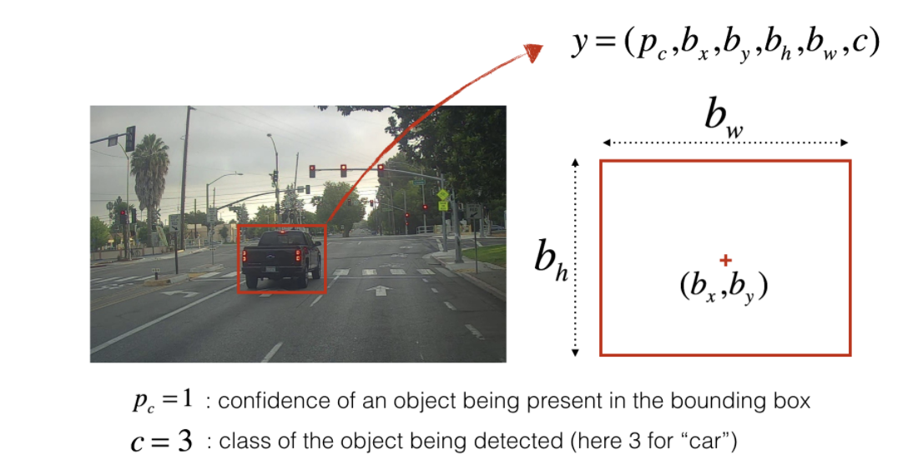Each bounding box is represented by 6 numbers: provides confidence of an object being present in the bounding box, the class of the object, and 4 coordinates (x,y centre points and height and width)
* Landmark detection – in more general cases, it may be more useful to have the neural network output only X and Y coordinates of important points of an image (known as landmarks) that you want the neural network to recognize. This is common in facial recognition

**Object detection details:**

* One approach to object detection is to use Sliding Windows, where you take little windows and slide them across every square region and classify each region as containing a car or not. But this is computationally very expensive
* Best approach is to implement Sliding Windows convolutionally. So instead of sequentially feeding sub regions into the ConvNet and classifying each sub region, you implement the entire image and convolutionally make all the predictions at the same time by one forward pass through the ConvNet. This is much more efficient but the bounding box coordinates will not be too accurate
* **YOLO algorithm** is commonly used in object detection problem as it produces more accurate bounding boxes
* You split the image into a grid (usually 19x19) and if the centre/midpoint of an object falls into a grid cell, that grid cell is responsible for detecting that object
* The layers of the neural network are constructed such that you end up with a 19x19x(no of classes + 4 coordinates + % confidence) output layer, so you can look through the results of each grid cell to check for detected images
* The coordinates of the object are expressed relative to the grid in which the object was detected
* Anchor boxes are chosen by exploring the training data to choose reasonable height/width ratios that represent the different classes
* If we use n anchor boxes, each of the 19 x19 cells thus encodes information about n boxes (note: N = 5 in the diagrams below)
* For simplicity, we will flatten the last two last dimensions of the shape

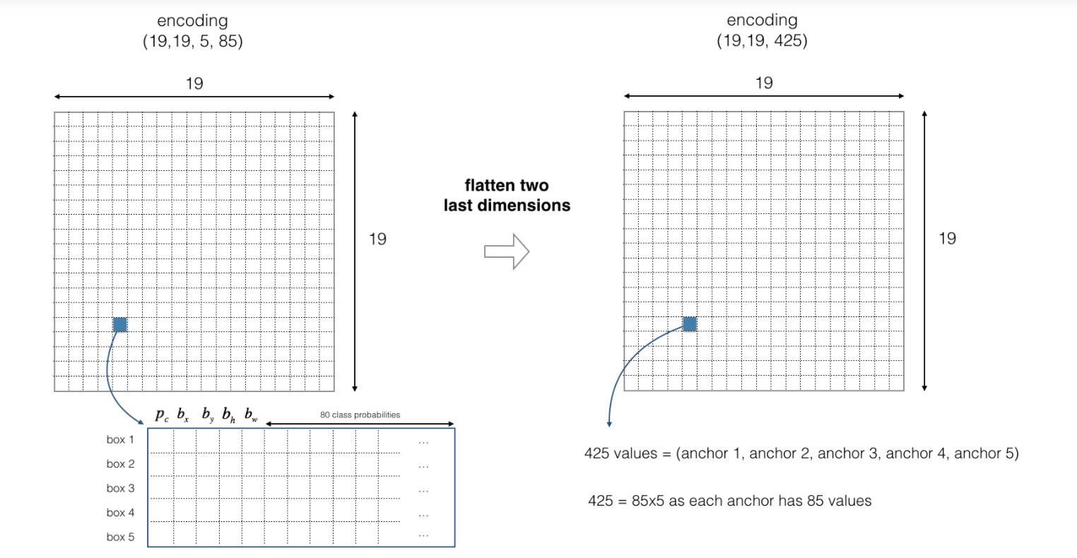

* for each box (of each cell) we will compute the following element-wise product and extract a probability that the box contains a certain class.
* The class score is scorec,i= pc × ci : the probability that there is an object pc times the probability that the object is a certain class ci.

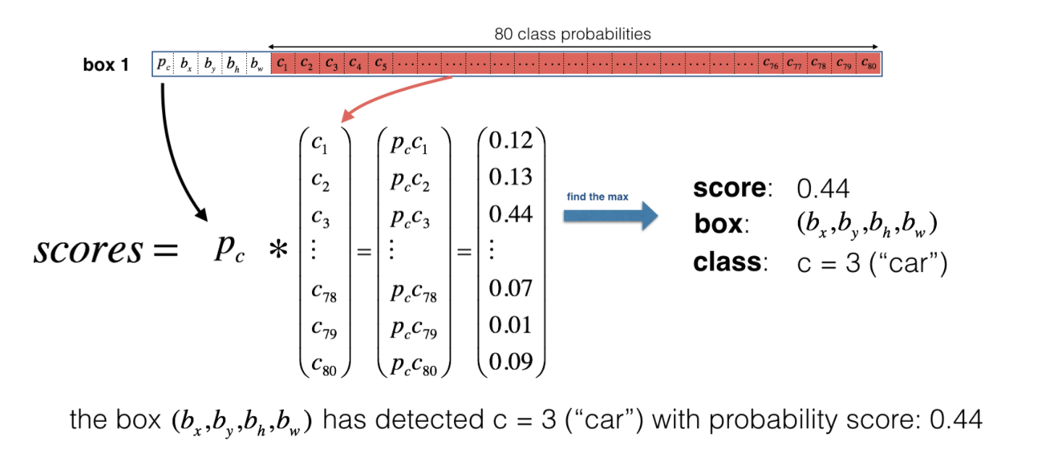

**Non-max suppression**: reduce the algorithm's output to a much smaller number of detected objects. Steps:

* 1. Get rid of boxes with a low score (meaning, the box is not very confident about detecting a class; either due to the low probability of any object, or low probability of this particular class).
  2. Select only one box when several boxes overlap with each other and detect the same object.

Intersection over union – measure of overlap which helps with scoring predictions, and also helps when performing non-max suppression

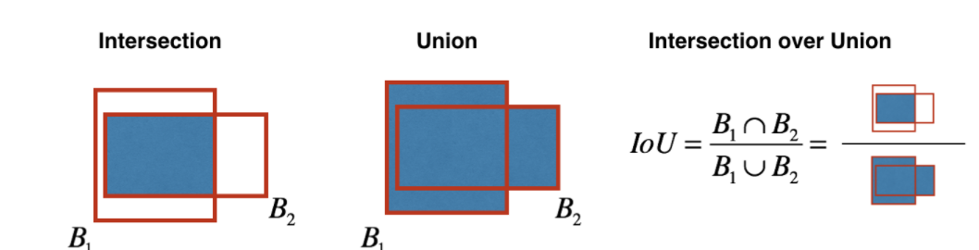

**Neural-style transfer**

* Neural Style Transfer (NST) merges two images, namely: a **"content" image (C) and a "style" image (S), to create a "generated" image (G**).
* Neural Style Transfer (NST) uses a previously trained convolutional network and builds on top of that. The idea of using a network trained on a different task and applying it to a new task is called transfer learning.
* The shallower layers of a ConvNet tend to detect lower-level features such as edges and simple textures.
* The deeper layers tend to detect higher-level features such as more complex textures as well as object classes.
* We would like the "generated" image G to have similar content as the input image C. You'll get the most visually pleasing results if you choose a layer in the **middle** of the network
* Set the image C as the input to the pretrained network and run forward propagation. Let a(C) be the hidden layer activations in the layer you had chosen. This will be an nH×nW×nC tensor.
* Repeat this process with the image G: Set G as the input and run forward propagation. Let a(G)a(G) be the corresponding hidden layer activation.
* 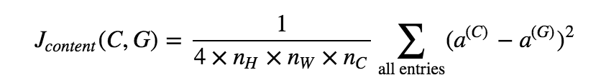We will define the content cost function as:

* Here, nH,nW and nC are the height, width and number of channels of the hidden layer you have chosen, and appear in a normalization term in the cost.
* For clarity, note that a(C) and a(G) are the 3D volumes corresponding to a hidden layer's activations.
* In order to compute the cost Jcontent(C,G), it might also be convenient to unroll these 3D volumes into a 2D matrix, as shown below.
* Technically this unrolling step isn't needed to compute Jcontent, but it will be good practice for when you do need to carry out a similar operation later for computing the style cost Jstyle.

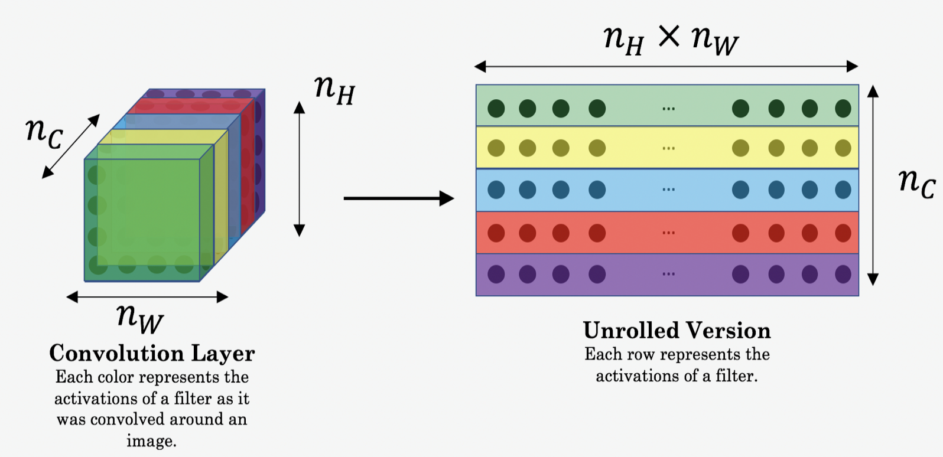

* The content cost takes a hidden layer activation of the neural network, and measures how different a(C) and a(G) are.
* Lets see how you can now define a "style" cost function Jstyle(S,G)
* In linear algebra, the Stye matrix / Gram matrix G of a set of vectors (v1,…,vn) is the matrix of dot products, whose entries are Gij=vTivj=np.dot(vi,vj)
* In other words, Gij compares how similar vi is to vj: If they are highly similar, you would expect them to have a large dot product, and thus for Gij to be large.
* In Neural Style Transfer (NST), you can compute the Style matrix by multiplying the "unrolled" filter matrix with its transpose: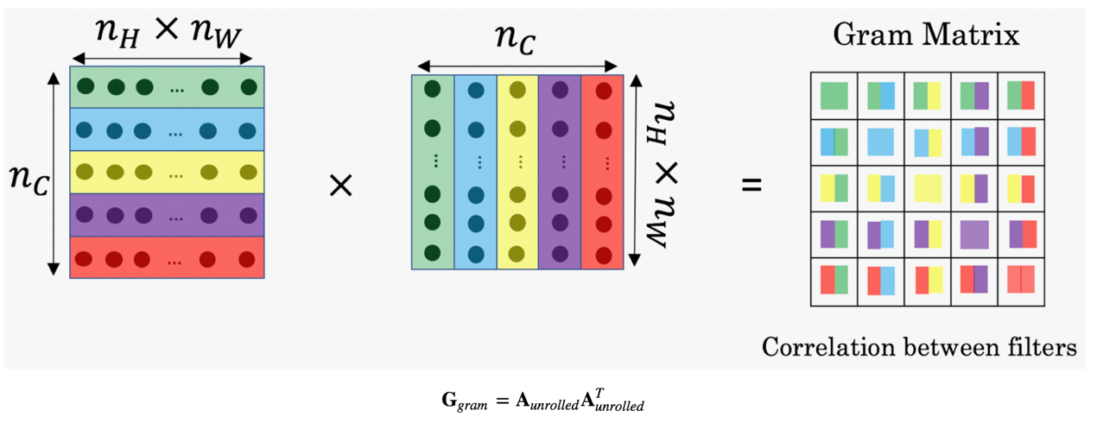
* The result is a matrix of dimension (nC,nC) where nC is the number of filters (channels). The value G(gram)i,j measures how similar the activations of filter i are to the activations of filter j.
* The diagonal elements G(gram)ii measure how "active" a filter i is.
* For example, suppose filter i is detecting vertical textures in the image. Then G(gram)ii measures how common vertical textures are in the image as a whole.
* If G(gram)ii is large, this means that the image has a lot of vertical texture.
* By capturing the prevalence of different types of features (G(gram)ii), as well as how much different features occur together (G(gram)ij), the Style matrix Ggram measures the style of an image.
* The style cost for a given layer is defined as:

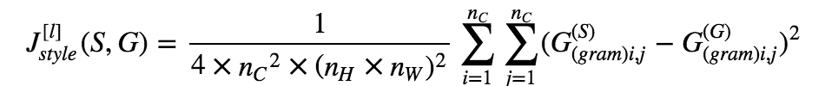

* G(S)gram  matrix of the "style" image.
* G(G)gram matrix of the "generated" image.
* Remember, this cost is computed using the hidden layer activations for a particular hidden layer in the network a[l]
* We'll get better results if we "merge" style costs from several different layers.
* Each layer will be given weights (λ[l]λ[l]) that reflect how much each layer will contribute to the style.

**Facial recognition**

* **Face Verification** - "is this the claimed person?".
* **Face Recognition** - "who is this person?".
* FaceNet learns a neural network that encodes a face image into a vector of 128 numbers. By comparing two such vectors, you can then determine if two pictures are of the same person.
* This network uses 96x96 dimensional RGB images as its input. Specifically, inputs a face image (or batch of mm face images) as a tensor of shape (m,nC,nH,nW)=(m,3,96,96)
* It outputs a matrix of shape (m,128) that encodes each input face image into a 128-dimensional vector
* Training will use triplets of images (A,P,N)(A,P,N):
* A is an "Anchor" image--a picture of a person.
* P is a "Positive" image--a picture of the same person as the Anchor image.
* N is a "Negative" image--a picture of a different person than the Anchor image.
* These triplets are picked from our training dataset. We will write (A(i),P(i),N(i)) to denote the i-th training example.
* You'd like to make sure that an image A(i) of an individual is closer to the Positive P(i)P than to the Negative image N(i) by at least a margin α, this the cost function is:

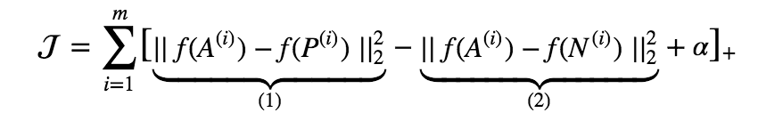

* Here, we are using the notation "[z]+[z]+" to denote max(z,0)max(z,0).
* The term (1) is the squared distance between the anchor "A" and the positive "P" for a given triplet; you want this to be small.
* The term (2) is the squared distance between the anchor "A" and the negative "N" for a given triplet, you want this to be relatively large. It has a minus sign preceding it because minimizing the negative of the term is the same as maximizing that term.
* α is called the margin. It is a hyperparameter that you pick manually. We will use α=0.

### Recurrent neural networks

* Recurrent Neural Networks (RNN) are very effective for Natural Language Processing and other sequence tasks because they have "memory"
* They can read inputs x⟨t⟩ (such as words) one at a time, and remember some information/context through the hidden layer activations that get passed from one time-step to the next.
* This allows a unidirectional RNN to take information from the past to process later inputs. A bidirectional RNN can take context from both the past and the future.

**Notation**:

* Superscript [l] denotes an object associated with the lthlth layer.
* Superscript (i) denotes an object associated with the ithith example.
* Superscript ⟨t⟩ denotes an object at the tthtth time-step.
* **Sub**script i denotes the ith entry of a vector.
* Basic structure of a RNN:

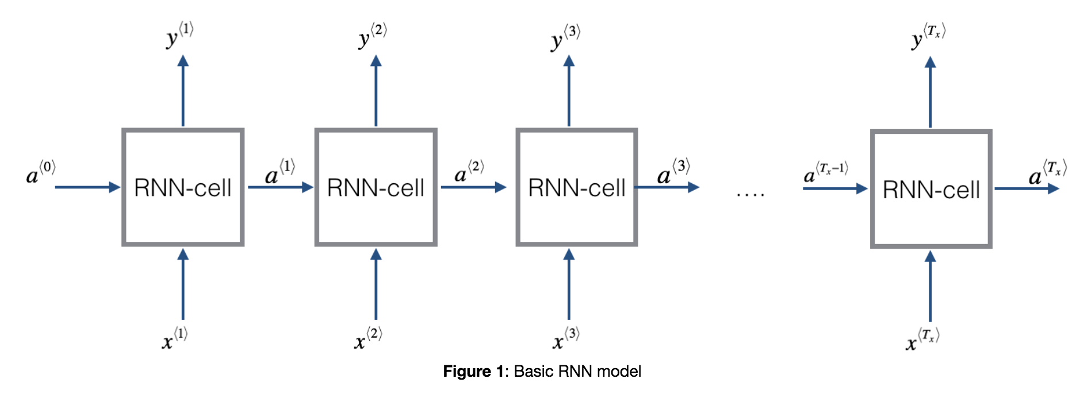

* For a single timestep of a single input example, x(i)⟨t⟩x(i)⟨t⟩ is a one-dimensional input vector.
* Using language as an example, a language with a 5000 word vocabulary could be one-hot encoded into a vector that has 5000 units. So x(i)⟨t⟩x(i)⟨t⟩ would have the shape (5000,).
* We'll use the notation nx to denote the number of units in a single timestep of a single training example.
* Standard RNN is not good at finding long term dependencies within a sequence (vanishing gradient problem)

**Gated recurrent unit**

* Memory cell in each unit (c<t>) which is equivalent to the activation value (a<t>)
* Each cell will have a gate (Γu ) will take a value of 0 or 1 (in practice it’s a sigmoid function). If 1, it will update c, 0 not update it
* And that means that important tokens can be carried forward to influence tokens later in the sequence. E.g. the token ‘cat’ might be given a value of 1, and then carried forward to help later sequence know that we are talking singular not plural
* Because Γ can be really close to 0, it doesn’t get affected by vanishing gradients

**LSTM (Long Short Term Memory)**

* LSTMs help to overcome vanishing gradient problems (generally better than Gated recurrent units)

A simple RNN cell:

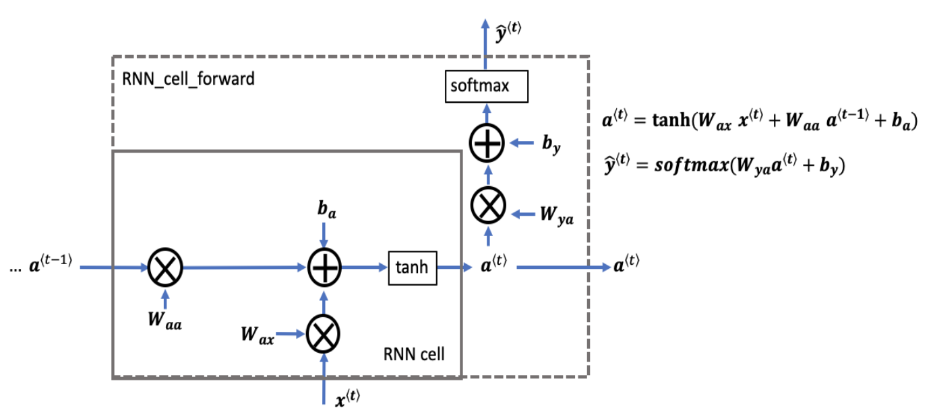

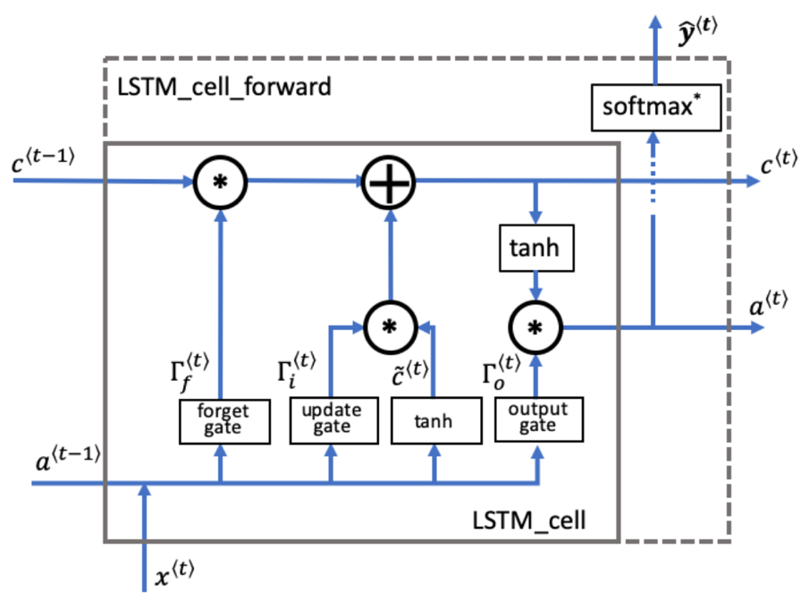An LSTM cell:

* It has 3 gates: forget gate, update gate and output gate
* Forget gate:

Γ⟨t⟩f=σ(Wf[a⟨t−1⟩,x⟨t⟩]+bf)

*Explanation of the equation:*

* Wf contains weights that govern the forget gate's behavior.
* The previous time step's hidden state [a⟨t−1⟩ and current time step's input x⟨t⟩] are concatenated together and multiplied by Wf
* A sigmoid function is used to make each of the gate tensor's values Γ⟨t⟩f range from 0 to 1.
* The forget gate Γ⟨t⟩f has the same dimensions as the previous cell state c⟨t−1⟩.
* This means that the two can be multiplied together, element-wise.
* Multiplying the tensors Γ⟨t⟩f∗c⟨t−1⟩ is like applying a mask over the previous cell state.
* If a single value in Γ⟨t⟩f is 0 or close to 0, then the product is close to 0.
  + This keeps the information stored in the corresponding unit in c⟨t−1⟩ from being remembered for the next time step.
* Similarly, if one value is close to 1, the product is close to the original value in the previous cell state.
  + The LSTM will keep the information from the corresponding unit of c⟨t−1⟩, to be used in the next time step.
* The candidate value **c̃⟨t⟩** is a tensor containing information from the current time step that **may** be stored in the current cell state c⟨t⟩.
* Which parts of the candidate value get passed on depends on the update gate.
* The candidate value is a tensor containing values that range from -1 to 1.
* The tilde "~" is used to differentiate the candidate c̃ ⟨t⟩ from the cell state c⟨t⟩.
* c̃⟨t⟩=tanh(Wc[a⟨t−1⟩,x⟨t⟩]+bc)

Update gate:

Γ⟨t⟩i=σ(Wi[a⟨t−1⟩,x⟨t⟩]+bi)

* We use the update gate to decide what aspects of the candidate c̃ ⟨t⟩ to add to the cell state c⟨t⟩.
* The update gate is a tensor containing values between 0 and 1.
  + When a unit in the update gate is close to 1, it allows the value of the candidate c̃ ⟨t⟩ to be passed onto the hidden state c⟨t⟩.
  + When a unit in the update gate is close to 0, it prevents the corresponding value in the candidate from being passed onto the hidden state.
* Notice that we use the subscript "i" and not "u", to follow the convention used in the literature.
* The update gate is multiplied element-wise with the candidate, and this product (Γ⟨t⟩i∗c̃ ⟨t⟩) is used in determining the cell state c⟨t⟩.

Cell state **c⟨t⟩**

* The cell state is the "memory" that gets passed onto future time steps.
* The new cell state c⟨t⟩ is a combination of the previous cell state and the candidate value.

c⟨t⟩=Γ⟨t⟩f∗c⟨t−1⟩+Γ⟨t⟩i∗c̃ ⟨t⟩

* The previous cell state c⟨t−1⟩ is adjusted (weighted) by the forget gate Γ⟨t⟩f
* and the candidate value c̃ ⟨t⟩ is adjusted (weighted) by the update gate Γ⟨t⟩i

#### Output gate **Γo**

Γ⟨t⟩o=σ(Wo[a⟨t−1⟩,x⟨t⟩]+bo)

* The output gate decides what gets sent as the prediction (output) of the time step.
* The output gate is like the other gates. It contains values that range from 0 to 1.
* The output gate is determined by the previous hidden state a⟨t−1⟩ and the current input x⟨t⟩
* The sigmoid makes the gate range from 0 to 1.

**- Hidden state**a⟨t⟩

* The hidden state gets passed to the LSTM cell's next time step.
* It is used to determine the three gates (Γf,Γu,Γo) of the next time step.
* The hidden state is also used for the prediction y⟨t⟩.

***Equation***

a⟨t⟩=Γ⟨t⟩o∗tanh(c⟨t⟩)

***Explanation of equation***

* The hidden state a⟨t⟩ is determined by the cell state c⟨t⟩ in combination with the output gate Γo.
* The cell state state is passed through the "tanh" function to rescale values between -1 and +1.
* The output gate acts like a "mask" that either preserves the values of tanh(c⟨t⟩) or keeps those values from being included in the hidden state a⟨t⟩)

**- Prediction**y⟨t⟩pred

* The prediction in this use case is a classification, so we'll use a softmax.

The equation is:

y⟨t⟩pred=softmax(Wya⟨t⟩+by)

### NLP / Attention / Transformer

Language tasks

RNN:

* Encodes each token in a sentence into a word vector, and then through NN

Attention mechanism – compute independent vector representation each token,

Transformer -

Token embeddings - vector representation of a token

Segment embedding - Label on whether sentence is 1st or 2nd in a sequence

Positional embeddings - Relative distance of tokens in a sequence

Add all of them and this serves as input to the Transformer

realmadridK5

happy to join the meeting if this framework will be beefi

### Unsupervised Learning

**K-means**

Most widely used clustering algorithm

Input – K (number of clusters), training set

Steps:

* 1. Randomly initialise K cluster centroids
  2. For each training example:

Index (from 1 to K) of cluster centroid closest to the training example

For each cluster:

Calculate average of points assigned to cluster K

K-means optimization objective:

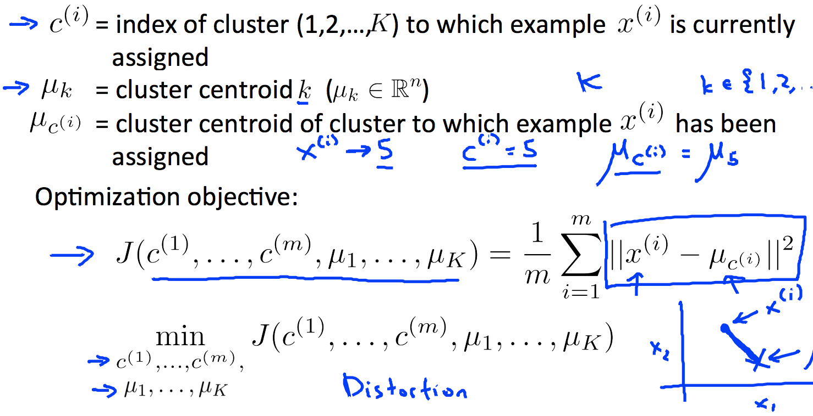

Random initialization guidance:

1. Should have K < m
2. Randomly pick K training examples
3. Set μ1,….., μK equal to these K examples
4. Perform random initialisation several times, computing the cost function each time. Then pick clustering that gave lowest cost

**Anomaly Detection**

1. Choose features that you may be indicative of anomalous examples

2. Get a training set of these features, where each example is not anomalous. Your validation / test set should have some anomalous examples in order to evaluate model performance

3. Check if features are relatively normally distributed. If not, transform them to make as normal as possible

4. Fit a model to the data's distribution: given a training set estimate the Gaussian (normal) distribution for each of the features (x)

Formula for Gaussian distribution:

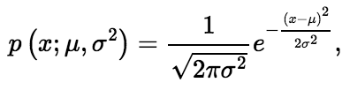where:

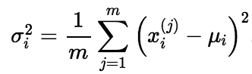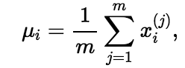and

5. Now that you have estimated the Gaussian parameters, you can calculate probability (p) for a new example. The low probability examples are more likely to be the anomalies in our dataset.

6. To determine which examples are anomalies, select a threshold based on a cross validation set (usually choose threshold based on the F1score on a cross validation set)

7. Perform error analysis to identify additional features:

- Find examples for feature x1 where an anomaly and non-anomaly have similar x1 value. Then think about what other feature might help differentiate between them

- Choose features that might have unusually large or small values in the event of an anomaly.

Multivariate Gaussian

Don’t model each feature separately – model in one go with covariance matrix:

XXX

Anomaly detection vs supervised learning:

**Principal Component Analysis (PCA)**

Most widely used algorithm used for dimensionality reduction

Steps:

* 1. Apply feature normalisation (and scaling if necessary)
  2. Compute covariance matrix (this will be an nxn matrix)

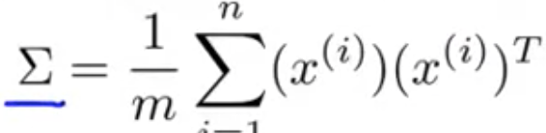

* 1. Compute eigen values using singular value decomposition linear algebra on the covariance matrix (Sigma)

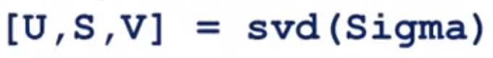

* 1. Note U is an nxn matrix. To reduce dimension from n to k, you need to subset the first k vectors of U to get K eigenvectors. Then project the eigenvectors into the smaller dimensional space by:

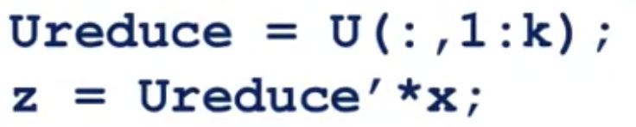

**Collaborative filtering learning systems (recommender system)**

* 1. Set up data in two matrices (X and Theta) where:

The ith row of X corresponds to the feature vector x(i) for the ith movie, and the jth row of Theta corresponds to one parameter vector θ(j), for the jth user.

### Large scale machine learning

* Standard gradient descent (known as batch gradient descent) can be slow when training set is in the hundreds of millions examples, calculating theta at each step involves summing over all training examples
* 4 ways to get around this: stochastic gradient descent, mini-batch gradient descent, online learning, and parallelisation
* Stochastic gradient descent – update theta after each individual training example
  1. Shuffle examples

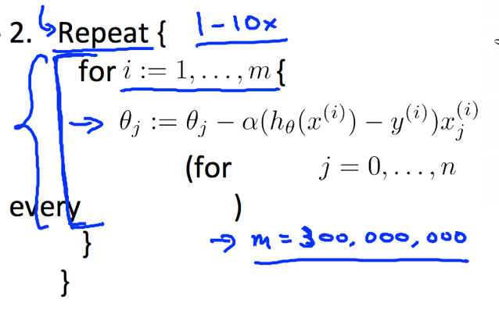

­

Note: check convergence by taking average cost every 1000 iterations and check its falling

Note 2: reduce learning rate after certain number of iterations to help ensure convergence

* Mini-batch gradient descent – Use *b* examples in each iteration rather than single example:

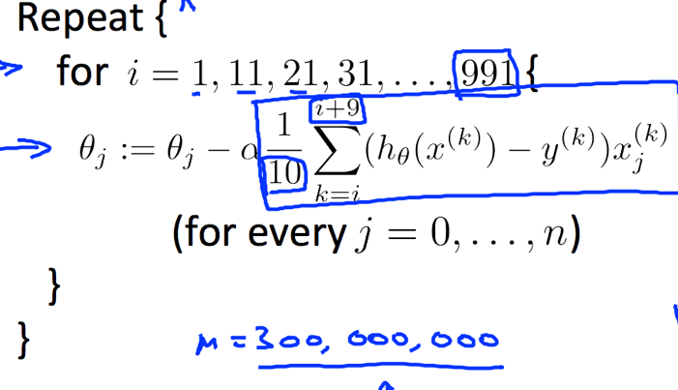

* Online-learning - data becomes available in a sequential order and is used to update the best predictor for future data at each step, as opposed to batch learning techniques which generate the best predictor by learning on the entire training data set at once
* Parallelisation

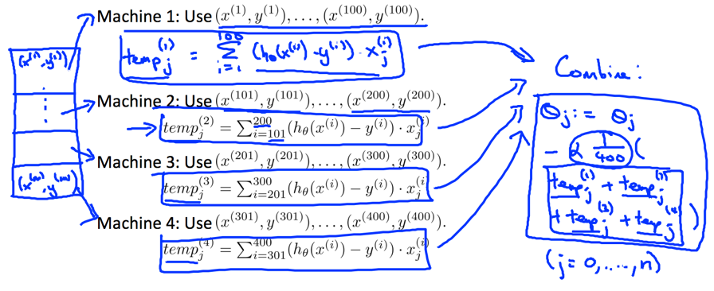

### Appendix A: Matrix algebra

**Notation and terms**:

* *Aij*​ refers to the element in the ith row and jth column of matrix A.
* A vector with 'n' rows is referred to as an 'n'-dimensional vector.
* *vi*​ refers to the element in the ith row of the vector.
* Matrices are usually denoted by uppercase names while vectors are lowercase.
* "Scalar" means that an object is a single value, not a vector or matrix.
* ℝ refers to the set of scalar real numbers.
* ℝ𝕟 refers to the set of n-dimensional vectors of real numbers.

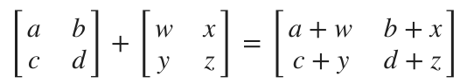

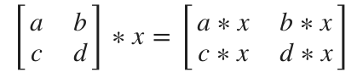

We map the column of the vector onto each row of the matrix, multiplying each element and summing the result.

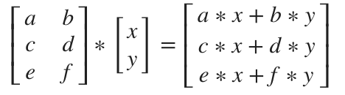

We multiply two matrices by breaking it into several vector multiplications and concatenating the result.

if A were an m×n. matrix, and B a  n×o matrix, then C would be  m×o. i.e. C will have the same number of rows as the 1st matrix, and the same number of columns as the 2nd matrix.

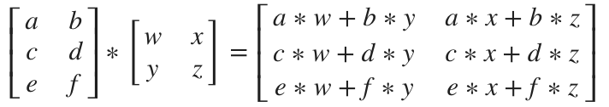

The **transposition** of a matrix is like rotating the matrix 90**°** in clockwise direction and then reversing it. We can compute transposition of matrices in matlab with the transpose(A) function or A':

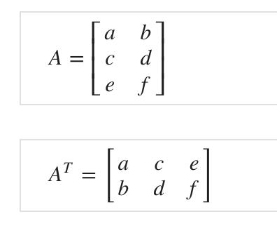

### Appendix B: Derivatives

### Appendix C: ML hardware

CUDA - a parallel computing platform and programming model developed by Nvidia for general computing on its own GPU